**Cavity sealing-**

**Pressure cup gun 3300 HSDR**

Art. no.: 33001 / 33101 / 33102 / 33103 / 33104

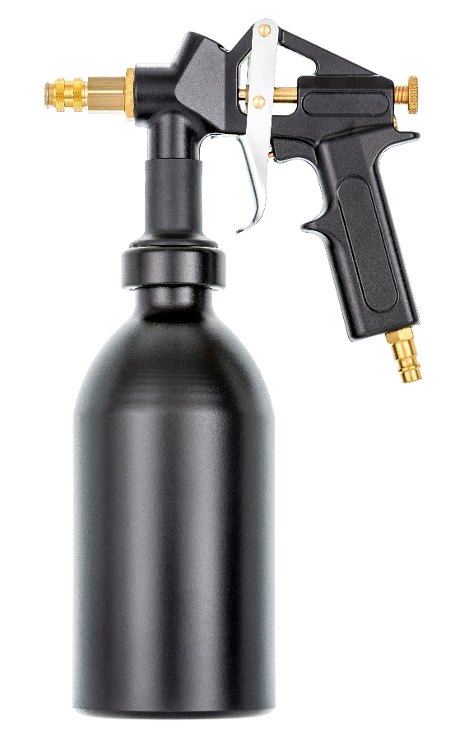



Thank you very much for the trust you have placed in us and our products.

[](https://www.google.de/url?sa=i&rct=j&q=&esrc=s&source=images&cd=&cad=rja&uact=8&ved=0ahUKEwj6nYTbvrXSAhVjEpoKHZXvAGoQjRwIBw&url=https://portal.tirol.gv.at/moodle/course/view.php?id%3D2158&bvm=bv.148441817,d.bGs&psig=AFQjCNErFAB2auuByAdHwkrRXyinyVQzsQ&ust=1488463996791759)

**Please read the operating manual first before working with the pressure cup gun.**

This operating and maintenance manual contains important information required for the safe and trouble-free operation of your pressure cup gun. Therefore, always keep this operating manual with the pressure cup gun.

**General notices:**

This pressure cup gun was developed for certain applications. We explicitly point out that this pressure cup gun must not be modified and/or used in a way that does not correspond to its intended use.

**Content:**

1. Technical data …………………………………………………………………….………………....... 3
2. Extent of delivery ……………………………………………………………………………………. 3
3. Intended use .……………………………………………………….…………….……………………. 3
4. Features .………………………………………………………………………………………….. ………. 3
5. Safety instructions …………………………………………………………….………………………. 3
6. Installation / end of work …………………………………………………………………………. 5
7. Maintenance and care …………………………………………………….……………………….. 5
8. Storage …………………………..………………………………………………..………………………. 6
9. Troubleshooting………………………………………………………………..…………………….… 6
10. Warranty terms …………….…………………………………………………………………………. 6
11. Address ……………………………………………………………………………………………………. 7
12. EC-declaration of conformity …………..………………………………....…………...……... 8
13. Notices ……………………………………………………………………………………………………… 9
14. Technical drawing …..….…………………..………………………………………………………. 10
15. Spare parts list …………………………………………………………………………………………. 11
16. **Technical data**

|  |  |
| --- | --- |
| **Description** | **3300 HSDR** |
|  |  |
| Operating pressure | 2-8 bar |
| Maximum pressure | 8 bar |
| Container volume | 1.250 ml |
| Connection thread for air | ¼“ |
| Compressed air connection | via quick coupling |
| Adjustable spray pattern | Adjustable material flow |
| Measurement | 329 x 164 x 93 mm |
| Measurement cardboard | 360 x 230 x 110 mm |
| Net weight | approx. 905 g |
| Gross weight | approx. 1.229 g |
| Weight 3900 WH 02/04 | 150 g * |
| Required air quality | filtered, condensate-free |

* included with 3300 HSDR-Set

1. **Extent of delivery**

Pressure cup gun, compressed air connection, operating manual

Additionally included with 3300 HSDR set: Hose set 3900 WH 02/04

1. **Intended use**

This pressure cup gun is a compressed air operated quality tool for professional use. It is suitable for processing liquid media in the form of loose containers.

1. **Features**

The effectiveness of the 3300 HSDR pressure cup gun is based on overpressure. For this purpose, pressure is built up in the pressure container by means of an air duct integrated in the gun body. This conveys the material present in the pressure container via a riser pipe to the material nozzle. When the lever is pressed, the material flows out of the material nozzle where it is mixed with the spray air.

1. **Safety instructions**

[](https://www.google.de/imgres?imgurl=http://www.stegaurach.de/images/2016/Feb/19/l_1442.png&imgrefurl=http://www.stegaurach.de/das-bayerische-landesamt-fuer-steuern-warnt-vor-betruegerischen-e-mails.&docid=V1_jVcaiOYtKIM&tbnid=jtIdzWwF_HMCaM:&vet=1&w=768&h=639&bih=889&biw=1829&q=symbole%20achtung&ved=0ahUKEwik4LzYvbXSAhVpOpoKHZtNDTEQMwgiKAEwAQ&iact=mrc&uact=8)**This pressure cup gun is not suitable for alkaline and acidic media.**

**Such media must not be processed with this pressure cup gun!**

Protect yourself and the environment by taking appropriate precautions against the risk of accidents and observe the following instructions in your own interest:

* The operator must ensure proper operation
* [](https://www.google.de/imgres?imgurl=http://www.stegaurach.de/images/2016/Feb/19/l_1442.png&imgrefurl=http://www.stegaurach.de/das-bayerische-landesamt-fuer-steuern-warnt-vor-betruegerischen-e-mails.&docid=V1_jVcaiOYtKIM&tbnid=jtIdzWwF_HMCaM:&vet=1&w=768&h=639&bih=889&biw=1829&q=symbole%20achtung&ved=0ahUKEwik4LzYvbXSAhVpOpoKHZtNDTEQMwgiKAEwAQ&iact=mrc&uact=8)Do not bring compressed air and/or medium into contact with skin or eyes.
* Never direct the spray jet at animals, people or yourself.
* Keep children and pets away from the operating area.
* No manipulations, emergency repairs or misappropriations may be carried out on the pressure cup gun.
* Pressure cup guns may only be operated and maintained by instructed persons.
* Repairs must only be carried out by qualified persons.

**The following applies to all maintenance and repair work:**

* It is essential to disconnect the pressure cup gun from the compressed air connection before carrying out maintenance or repair work.
* Only use original spare parts.
* The maximum working pressure must not be exceeded (see point 1 "Technical data"). The working pressure must be adjusted via a (filter) pressure reducer.
* Only use compressed air as energy source.
* The compressed air connection may only be made via a quick coupling.
* When working with the pressure cup gun, wear the necessary protective clothing, protective goggles, work gloves, ear protection if necessary and a respirator mask.
* If there are leaks in the device or other operating faults, the device must be disconnected from the compressed air supply immediately and the cause of the fault must be eliminated.
* Open fire, sparks or smoking is prohibited.
* Beware of flammable materials.
* Processed media and cleaning media must be disposed of in an environmentally friendly manner.
* The disposal of the compressed air device must be carried out according to the valid legal regulations.

1. **Installation/ end of work**

Preparing the gun for the first start-up: Screw in the compressed air connection and tighten it firmly using a 13 mm open-end wrench or ring spanner, if

necessary glue it in place.

*With optional pressure regulator instead of air volume regulation:* Screw the pressure gauge included in the extent of delivery into the pressure regulator, if necessary glue it in.

Start-up: Unscrew the pressure container and fill the medium into the container. Then hand-tighten the gun with the container cover onto the pressure container. Do not use any tools for this! Plug the connecting nipple of the hose (type 3900 or 3901) onto the quick coupling and let it engage. Connect the gun to the compressed air supply via the quick coupling of the air connection. By operating the trigger you put the pressure cup gun into operation.

[](https://www.google.de/imgres?imgurl=http://www.stegaurach.de/images/2016/Feb/19/l_1442.png&imgrefurl=http://www.stegaurach.de/das-bayerische-landesamt-fuer-steuern-warnt-vor-betruegerischen-e-mails.&docid=V1_jVcaiOYtKIM&tbnid=jtIdzWwF_HMCaM:&vet=1&w=768&h=639&bih=889&biw=1829&q=symbole%20achtung&ved=0ahUKEwik4LzYvbXSAhVpOpoKHZtNDTEQMwgiKAEwAQ&iact=mrc&uact=8) **Attention:**

Wear heat-resistant gloves when using

heated medium. Danger of burns!

The spray pattern can be influenced by the following factors:

* Material quantity via stop screw/nozzle needle
* Adjusting the intake pressure (optional)
* Distance between hand spray nozzle and object
* Angular position of the manual spray nozzle to the object

End of work: Vent the pressure container by turning the pressure container counterclockwise. Disconnect the device from the compressed air supply after each use. Clean the device and the hoses according to the instructions.

**Attention:**

[](https://www.google.de/imgres?imgurl=http://www.stegaurach.de/images/2016/Feb/19/l_1442.png&imgrefurl=http://www.stegaurach.de/das-bayerische-landesamt-fuer-steuern-warnt-vor-betruegerischen-e-mails.&docid=V1_jVcaiOYtKIM&tbnid=jtIdzWwF_HMCaM:&vet=1&w=768&h=639&bih=889&biw=1829&q=symbole%20achtung&ved=0ahUKEwik4LzYvbXSAhVpOpoKHZtNDTEQMwgiKAEwAQ&iact=mrc&uact=8)Never operate the trigger while the container is under pressure but the pressure cup gun is not connected to the compressed air source. This can push the medium into the air ducts and render the pressure cup gun unusable!

1. **Maintenance and care**

Clean the compressed air device after each use. Fill the pressure tank with cleaning medium and flush the pressure cup gun and the hoses (if present) by starting the device.

We recommend benzine or commercially available turpentine-based cleaners. Do not use aggressive cleaning media! Following the maintenance instructions will ensure a long service life and trouble-free operation for this quality product.

[](https://www.google.de/imgres?imgurl=http://www.stegaurach.de/images/2016/Feb/19/l_1442.png&imgrefurl=http://www.stegaurach.de/das-bayerische-landesamt-fuer-steuern-warnt-vor-betruegerischen-e-mails.&docid=V1_jVcaiOYtKIM&tbnid=jtIdzWwF_HMCaM:&vet=1&w=768&h=639&bih=889&biw=1829&q=symbole%20achtung&ved=0ahUKEwik4LzYvbXSAhVpOpoKHZtNDTEQMwgiKAEwAQ&iact=mrc&uact=8)

**Attention:**

Pay attention to a proper disposal of the residues, which arise during the maintenance and care.

1. **Storage**

The compressed air tool must be stored under the following conditions:

* If residual material is present, store only upright.
* Carefully clean the pressure cup gun after each use.
* Store in a dry and dust-free place.
* Do not expose to liquids and/or aggressive chemicals.
* Keep out of the reach of children.

1. **Troubleshooting**

In all cases of malfunction, please first check whether there is sufficient compressed air available, whether the spray material can still be processed, whether the expiry date has passed or whether the material has dried out.

* **Gun sprays messy**

Possible cause: Working pressure too low, nozzles are dirty.

Solution: Increase working pressure, clean nozzles.

* **Gun does not spray any material**

Possible cause: The riser pipe and/or nozzles are blocked.

Solution: Clean clogged parts.

* **Air escapes from the spray nozzle** even though the trigger is in its initial position

Possible cause: Valve bolt is jammed.

Solution: Pour oil onto the valve bolt and/or into the compressed air intake. Operate the trigger several times.

* **Material exits the spray nozzle** even though the trigger is in its initial

position.

Possible cause: The nozzle needle is jammed or dirty.

Solution: Clean the nozzle needle, apply oil to the nozzle needle and/or slightly reduce the pressure on the nozzle needle seal using a 9mm wrench. In order to ensure error-free use, a clamping effect on the nozzle needle seal must remain. Press the trigger several times.

1. **Warranty terms**

The basis for all warranty claims is the complete pressure cup gun and the proof of purchase. Damage caused by improper handling of the pressure cup gun is not covered by the warranty.

If you have any questions, please indicate the type description or the article number of the pressure cup gun.

* In conformity with legal regulations, you receive a 24-month warranty on all products against material and manufacturing defects.

Excluded from the warranty:

* Wear parts.
* Damage caused by improper use
* Damage caused by lack of maintenance.
* Damage caused by dirt.
* Damage caused by untreated compressed air.

If warranty claims are made, the pressure cup gun must be in its original condition.

1. **Address**

In case of service your sales representative is at your side or contact the following address:

Vaupel GmbH

Gerätebau & Drucklufttechnik

Am Forsthaus 6

35713 Eschenburg-Simmersbach

Germany

Telephone: +49 (0) 2774 80069-0

E-Mail: info@vaupel-gmbh.de

Internet: [www.vaupel-gmbh.de](http://www.vaupel-gmbh.de)

**Notice**: We reserve the right to make technical changes. Illustrations may differ from the original. We assume no liability for printing errors.

1. **EC-declaration of conformity**

|  |
| --- |
| **EG – Konformitätserklärung**  **Im Sinne der EG – Richtlinie Maschine 2006/42/EG,**  Product description: Pressure cup gun  Type designation: Type 3300 HSDR  Type description: Cavity sealing pressure cup gun  Article number manufacturer: 33001, 33101, 33102, 33103, 33104  Is developed, designed and manufactured in accordance with the above EC Directives, under the general responsibility of  Company: Vaupel GmbH  Gerätebau & Drucklufttechnik  Am Forsthaus 6  35713 Eschenburg-Simmersbach  The technical documentation is complete.  The following harmonised standard has been applied:  DIN EN ISO 12100 - **Sicherheit von Maschinen – Allgemeine Gestaltungsleitsätze - Risikobeurteilung und Risikominderung**  The operating instructions belonging to the machine are available in the original version and in the respective national language.    Simmersbach, 01.04.2020  Place, Date Signature, Managing director |

1. **Notices**
2. **Technical drawing**

j0340266[1]

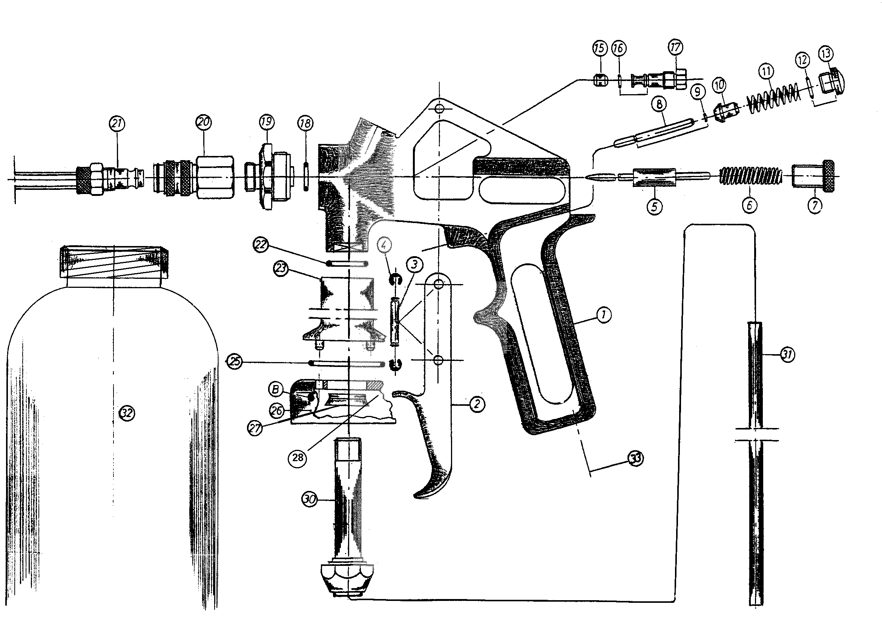

1. **Spare parts list**

|  |  |  |
| --- | --- | --- |
| **Pos.** | **Article no.** | **Discription** |
| 1 |  | Gun body |
| 2 | 50 3909 005 | Trigger |
| 3 | 30 1102 006 | Lever axis |
| 4 | 60 3100 029 | Lock washer |
| 5 | 83010 | Nozzle needle complete |
| 6 | 60 3104 007 | Spring for nozzle needle |
| 7 | 30 1122 005 | Lock screw |
| 8 | 80158 | Valve bolt |
| 9 | O-ring 1.5 x 0.75 mm |
| 10 | Valve seal |
| 11 | 60 3103 003 | Spring for valve |
| 12 | 60 4100 362 | O-ring 8 x 1 mm |
| 13 | 30 1120 002 | Locking screw |
| 14 |  |  |
| 15 | 40 4100 003 | Needle seal Teflon |
| 16 | 60 4100 364 | O-ring 5 x 1 mm |
| 17 | 30 1421 012 | Needle gland nut |
| 18 | 60 4100 366 | O-ring 8 x 2,5 mm |
| 19 | 30 2122 005 | Nozzle head |
| 20 | 20 1413 001 | Quick coupling |
| 21 | see accessories list | Cavity spray hose (accessory) |
| 22 | 60 4100 371 | O-ring 15 x 2 mm |
| 23 | 40 4104 014 | Adapter 3000 |
| 24 |  |  |
| 25 | 60 4100 372 | O-ring 33 x 2 mm |
| 26 | 10 2111 014 | Cup holder |
| 27 | 60 4100 344 | U-cup 12 x 18 x 4,5 x 1,6 |
| 28 | 60 4100 387 | O-ring 35 x 4 mm |
| 29 |  |  |
| 30 | 83302 | Fixing screw |
| 31 | 60 3129 014 | Riser pipe |
| 32 | 83305 | Pressure container |
| 33 | 30 1423 002 | Compressed air connection D (optional) |
| 33 | 30 1423 001 | Compressed air connection F (optional) |
| 33 | 30 1413 002 | Compressed air connection CH (optional) |
| 33 | 30 1422 001 | Compressed air connection ¼" AG (optional) |